# Exemplar: Adding a calculated table and column

## **Overview**

In the exercise *Adding a calculated table and column*, you were asked to create new calculated tables and columns using DAX within your data model to address specific analytical and visualization concerns.

Your tasks in this exercise were to:

* Create a calculated table from the existing dataset within your data model.
* Add calculated columns to a specific table within the dataset.
* Ensure data standardization and consistency.

This reading provides you with a step-by-step guide for completing these tasks. It also includes screenshots that you can compare against your work.

You can also review the [*Introduction to calculated tables*](https://www.coursera.org/learn/data-modeling-in-power-bi/lecture/OLf8s/introduction-to-calculated-tables) and [*Creating calculated columns*](https://www.coursera.org/learn/data-modeling-in-power-bi/lecture/Jkzfj/creating-calculated-columns) videos for guidance on using DAX in Power BI.

## **Step 1: Download and connect to the Adventure Works Dataset.**

1. Download the workbook from the exercise page on the Coursera platform.

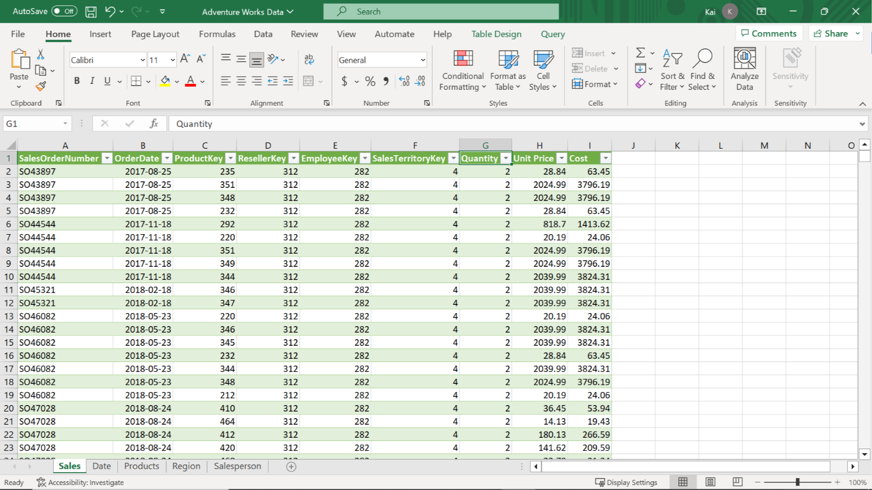

1. Launch Power BI desktop. To create a new project, select the File menu, then select New. Import the Adventure Works dataset that you have downloaded. In the Home tab, select the Get Data drop-down menu. Then select an appropriate data source. For the current exercise, select Excel Workbook and navigate to the Adventure Works dataset folder.

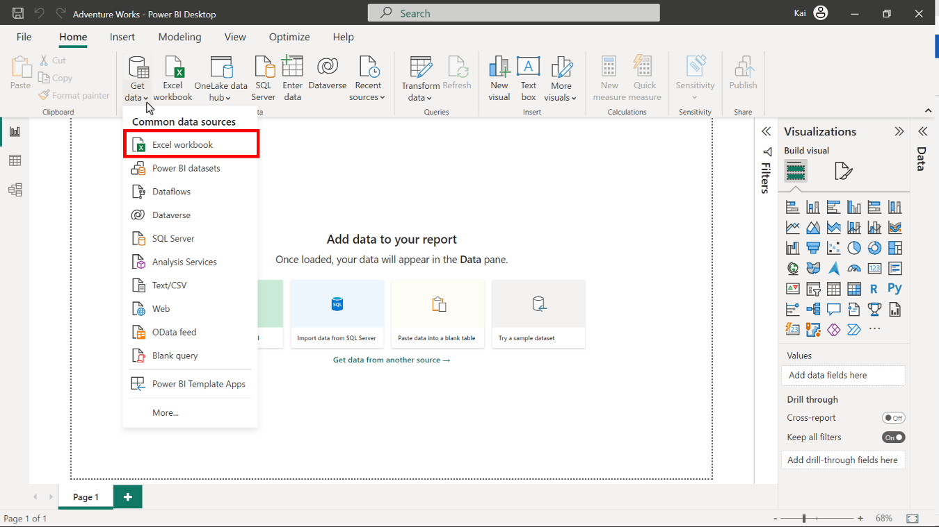

3. Once you select and load the data, Power BI opens a Navigator dialog box that lists all the tables available to load in the Excel file, along with the data preview on the right side of the Navigator. Select the Sales, Product, Region, Date, and Salesperson tables, then select Load.

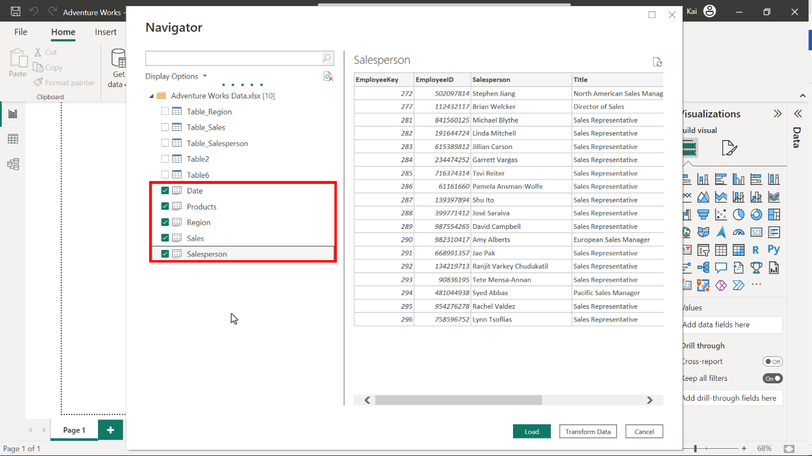

## **Step 2: Remove all duplicate values and set the relationships between the tables.**

1. To eliminate all duplicate data, access the Power Query editor, right-click on the SalesOrderNumber columns, and select Remove duplicates from the drop-down menu.

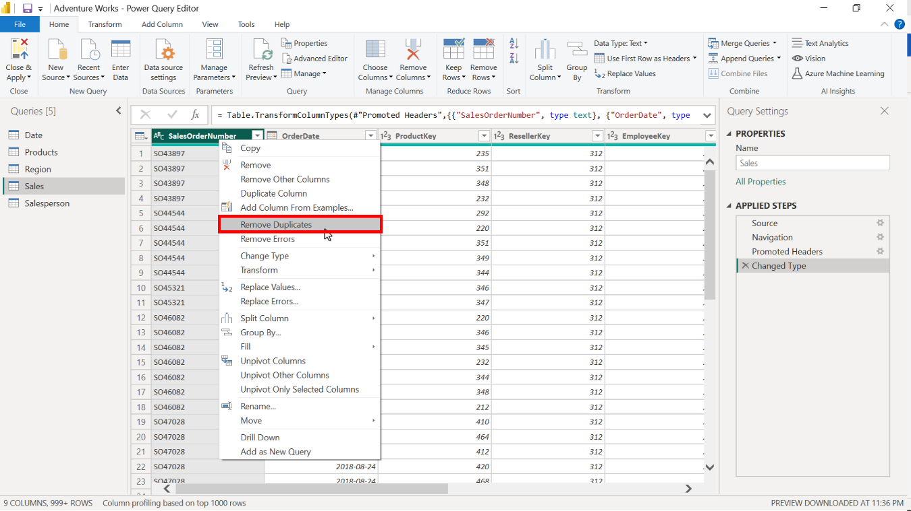

1. To configure the model relationships, access the Model view of Power BI desktop and select Manage relationships. From here, you can edit cardinality and cross-filter direction between the tables.

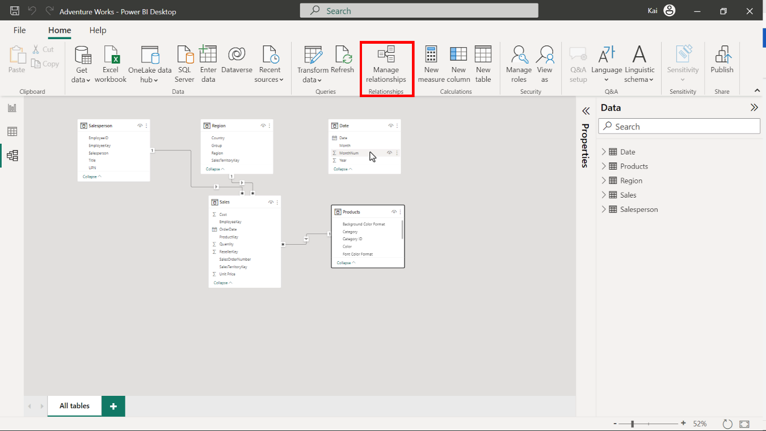

## **Step 3: Create a calculated table.**

1. Access the Model view in the calculations group to create a new table. Select New table. Copy and paste the following DAX code into the formula bar:

1

2

3

4

5

Yearly Sales by color =

ADDCOLUMNS (

Sales,

"Year", RELATED ( 'Date'[Year]),

"Color", RELATED ( Products[Color]))

* ADDCOLUMNS: Adds calculated columns to the given table or table expression. In this instance, the Sales table is the main table to which you need to add two more columns, one from the Date table and one from the Product table.
* Year and Color in double quotes are the names of the new columns to be added in the new calculated table.
* RELATED: Returns a related value from another table. In this case, Product color values from the Product table and Year information from the Date table.

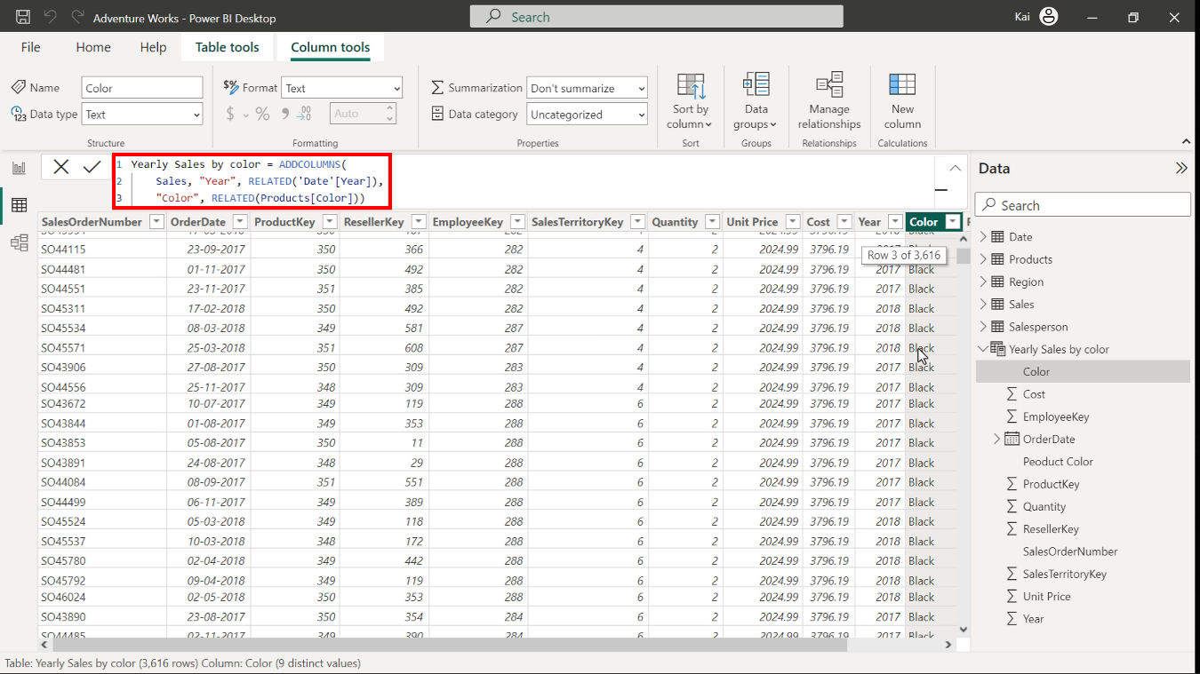

1. Note that the resulting table has 11 columns.

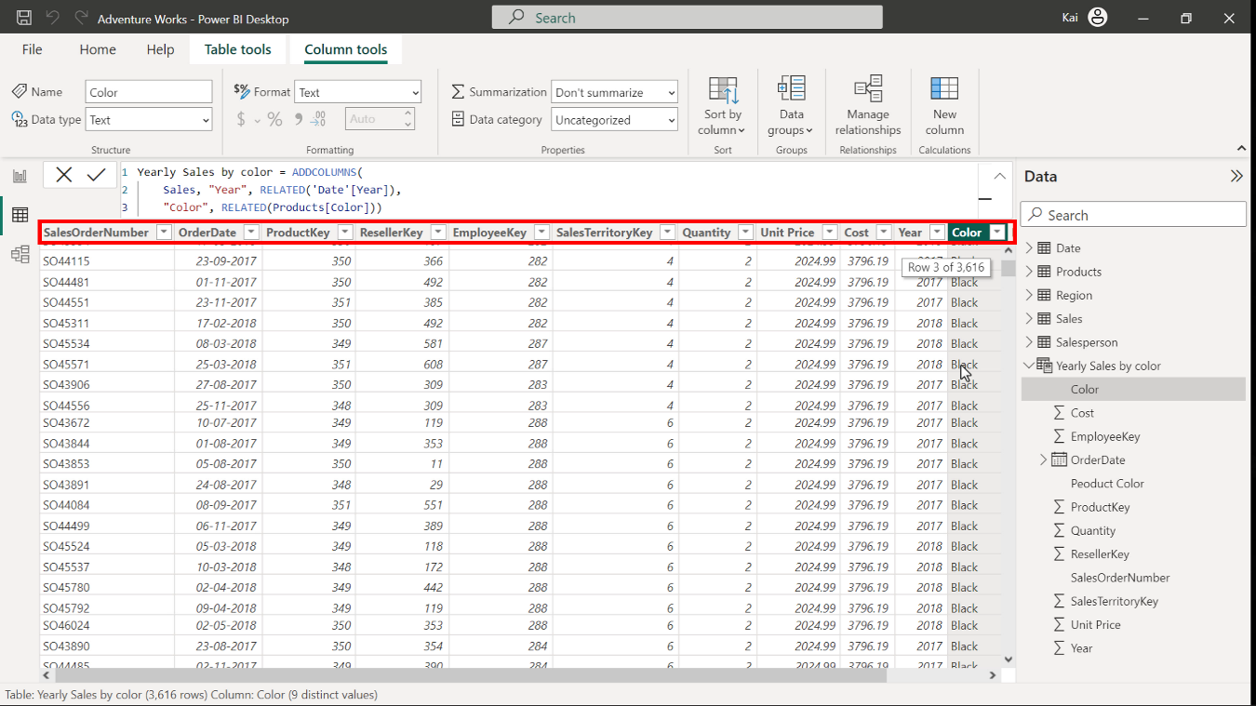

## **Step 4: Create calculated columns.**

1. To create a new column, select the Date table from the Data pane on the right side of Power BI interface. Access Model view in the Calculations group and select New column. Copy and paste the following DAX code into the formula bar:

1

Qtr = QUARTER('Date'[Date])

* QUARTER: Returns each quarter as a number from the Date column.
* Date in single quotes is the table, and Date in square brackets is the column within the table.

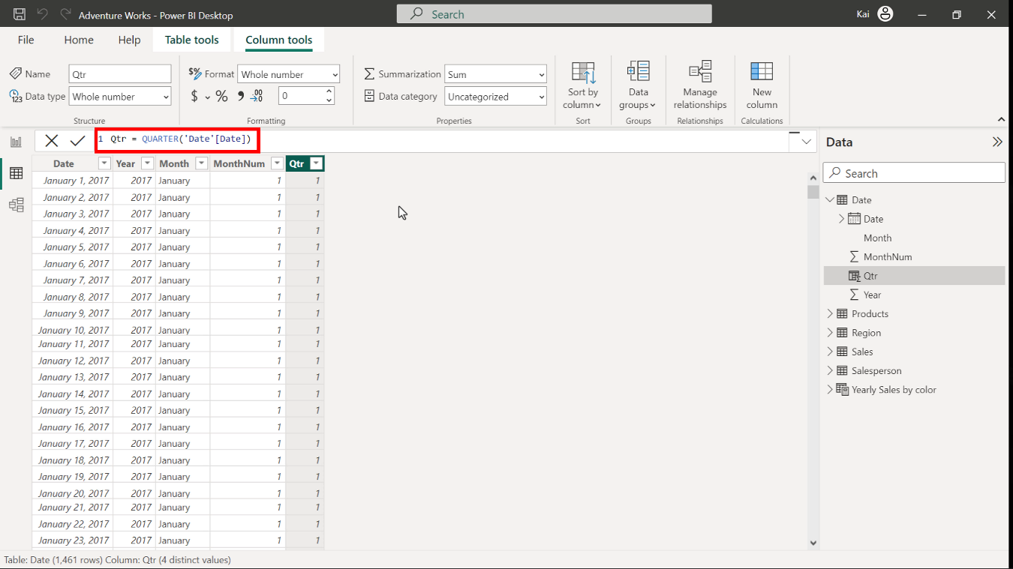

1. Select the Date table from the Data pane on the right side of Power BI interface. Access Model view in the Calculations group and select New column. Copy and paste the following DAX code into the formula bar:

1

Month =LEFT ( 'Date'[Month], 3 )

* LEFT: Returns the specified number of characters from the start of a text string.
* Date in single quotes is the table to be referenced, and Month in square brackets is the column name. The number 3 specifies the number of characters in the short month column.

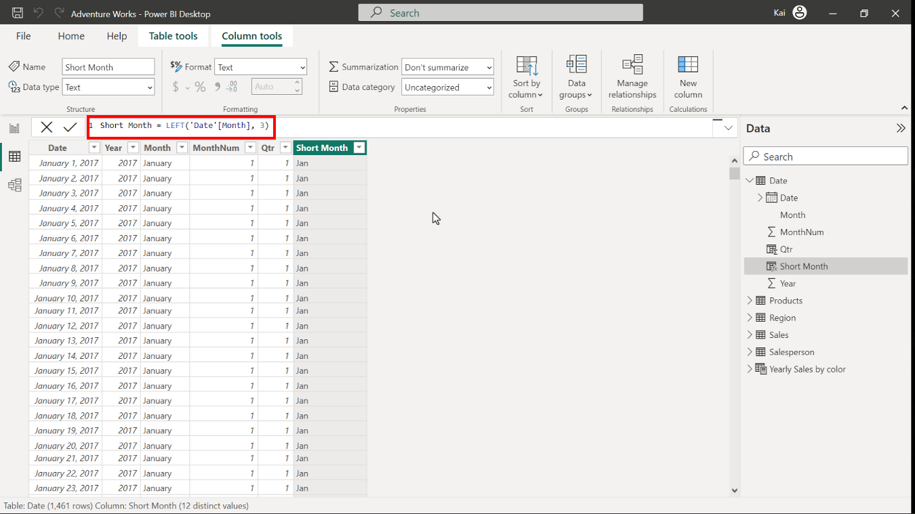

1. To create a new column, select the Product table from the Data pane on the right side of Power BI interface. Access Model view in the calculations group. Then select New column to expand the formula bar. Copy and paste the following DAX code into the formula bar:

1

Product Color = RELATED ( Products[Color] )

* RELATED here is the same as referencing a column from another table.

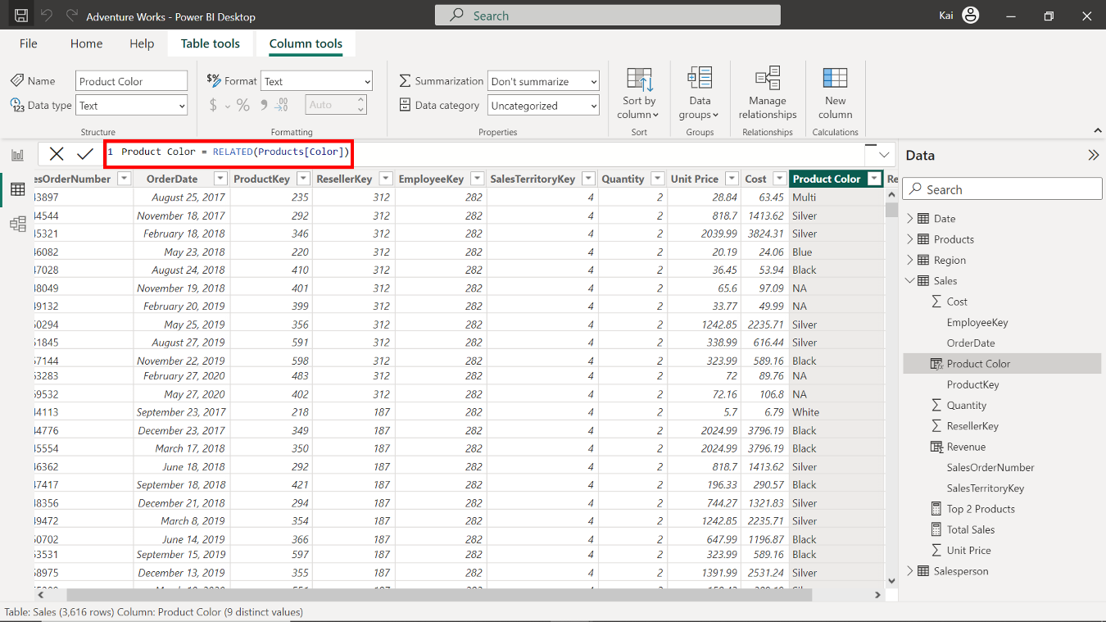

## **Step 5: Save your Power BI project.**

* To save the project, open the File menu, select Save As, and provide an appropriate name for the project along with a path to the folder on your computer.

## **Conclusion**

With these steps, you have successfully created a calculated table by combining data from multiple datasets and user-defined columns using DAX. You can now analyze Adventure Works data based on the analytical and business requirements.

Remember that when using DAX formulas, always ensure they are correctly formatted and that the column names match the actual column names in your data.